Área de Superficie de solidos
- Cilindro: A_{s} = 2 π r (r + h)

h = 10 cm.
r = 5 cm.
A_{s} = 2 π (5) (5 + 10)
= 10π (15) = 150π cm²

- Cono: A_{s} = π r (r + g)
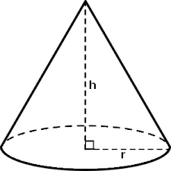
g = 7 cm.

r = 4 cm.
A_{s} = π 4 (4 + 7)
= π 4 (11) = 44π cm²

- Prisma rectangular: A_{s} = 2ab + 2ac + 2bc
c = 3
b = 2
a = 4
A_{s} = 2ab + 2ac + 2bc
A_{s} = 2(4)(2) + 2(4)(3) + 2(2)(3)
A_{s} = 2(8) + 2(12) + 2(6)
A_{s} = 16 + 24 + 12 = 52 cm²

a
- Cubo A_{s} = 6 a² = 6(3²)
= 6(9) = 54 cm
a = 3
a

- Pirámide rectangular: A_{s} = l (a) + h(l + a)
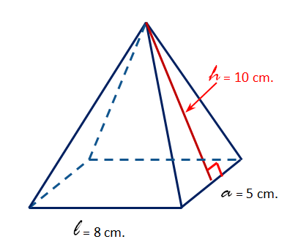
A_{s} = largo(ancho) + altura(largo + ancho)
A_{s} = l (a) + h(l + a)
A_{s} = 8 (5) + 10(8 + 5)
A_{s} = 40 + 10(13)
A_{s} = 40 + 130 = 170 cm²

- Esfera: A_{s} = 4π r²
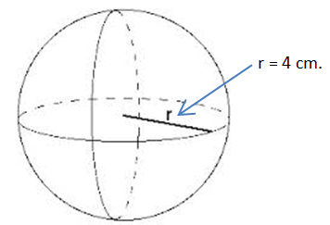
A_{s} = 4π r²
A_{s} = 4π (4²)
A_{s} = 64π cm²

